Name Mohammed R. M. Jaradat
BDS., MSc.(ortho), JB in orthodontics

Application as a Teaching Member of the Dental Faculty at Arab American University of Jenin

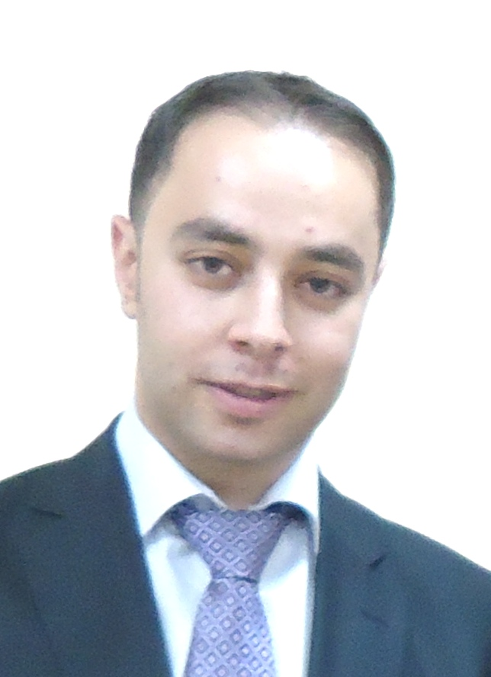

Personal Data

Date of Birth: 15th July 1985
Place of Birth: Nablus-Palestine
Marital Status: married
Nationality: Palestinian

Address: Private Orthodontics Clinic
Abu Baker Street
Jenin
Palestine

Telephone: +972 (0) 4-2502032
Mobile: +972 (0) 0595312298
E-mail mojaradat@hotmail.com
mohammed.jaradat@aaup.edu

CURRECULUM VITA

Personal Data | Name: Mohammed R. M. Jaradat  Address: Private Orthodontics Clinic  Abu Baker Street  Jenin  Palestine  Place of Birth: Nablus-Palestine  Marital Status: married  Nationality: Palestinian
Bachelor Qualification | 2003-2008 | Bachelor of Dental Surgery (BDS), Arab American University of Jenin. Jenin, Palestine.
Postgraduate Qualifications | Sept. 2009-Jan. 2012  2013 | Master in Dental Sciences (Orthodontics), Jordan University Of Science and technology, Irbid, Jordan.  Jordanian Board in Orthodontics, Jordanian Medical Council, Amman, Jordan  Palestinian board in orthodontics in 2014
Thesis  Honours and Awards | 31-10-2011  2008  2012 | Title: Tensile and compressive shear bond strength of orthodontic molar tubes bonded using different bonding techniques (under supervision of Prof. Dr.Elham Abu Al-Haija & Prof. Ahed Al-Wahadni)  Ranked first among all graduated (dental and university) students with a GPA of 3.98.  Excellent standing with an average of 88% (Master degree in orthodontics-Jordan university of science and technology-2012)
Clinical Experience | Oct. 2008-Aug. 2009  Jan. 2012-Jan. 2013  Currently | Teaching and research assistant, Dental Teaching centre/ Faculty of Dentistry, Arab American University Of Jenin. Jenin, Palestine  Clinical attachment /advanced training in orthodontics. Jordan University Of Science and technology, Irbid, Jordan  Working at Private Orthodontic Clinic
Research Interests |  | - Orthodontic management of cleft lip and palate cases.  - Application of micro-implants with fixed functional appliances.
Memberships in Scientific and Professional Societies: | Since 2013  Since 2013 | Palestinian Orthodontic Society  World Federation of Orthodontists (WFO).
Methodological Experiences |  | Laboratory measurements of tensile and compressive shear bond strengths of orthodontic attachments using Instron machines.
Publications |  | - Mohammad Jaradat, Ahmad Rahhal. Obstructive Sleep Apnea, Prevalence, Etiology & Role of Dentist & Oral Appliances in Treatment: Review Article. Open Journal of Stomatology, 2015, 5, 187-201  - Mohammed jaradat,ahmad Rahhal. orthodontic considerations of traumatized permanent teeth.British Journal of Medicine & Medical Research 15(9): 1-8, 2016,  - Abu al haija. et al .An Ex-vivo Shear and tensile bond strengths of orthodontic molar tubes bonded using different techniques journal of Clinical and Experimental Dentistry. march 2017:9(3)  - Mohammed jaradat.an Overview of Class III Malocclusion (Prevalence, Etiology and Management). March 2018Journal of Advances in Medicine and Medical Research 25(7):1-13  - Mohammed jaradat, waddah ardah. Orthodontic Intrusion of over Erupted Permanent Maxillary Molars Using Temporary Anchorage Devices. May 2019Open Journal of Stomatology 09(05):95-101.  - Jaradat et al. Prevalence of temporomandibular disorders among Palestinian medical students. World Journal of Advanced Research and Reviews, 2020, 06(01), 146-152.  - Rahhal Ahmad, Ahmead Muna, Mohammed Jaradat, Issa Haytham. Bruxism in children, is it a result of psychological problems? World Journal of Advanced Research and Reviews, 2020, 07(01), 234-244.
Conferences, Scientific Lectures and Workshops |  | The 6th Palestinian dental congress 7-9 April 2009, Jericho, Palestine.  Effective and efficient treatment modality: interactive self ligation- in ovation by Dr. Mladen M. Kuftinec, 26th oct.2010.  The 7th Jordanian orthodontic congress, April, 2011.  Comprehensive course: New aspects of orthodontic therapy : an evidence based overview by Professor William R. Proffit, 10th & 11th of nov.2011  Bag of Tricks: Your Guide to management of complicated orthodontic cases,( 6 CME hours course) by Prof. Bakr Rabie, April 8th ,2011.  Early orthodontic treatment: evidence –based or practice management (6 CME hours course) by Prof. Peter Ngan, April 5th , 2011.  An orthodontic course titled: AS.T.A.M.P FOR ORTHODONTIC SUCCESS by Prof. Yehya Mustafa Feb, 22, 2012.  An orthodontic course titled: new solutions to old problems: optimized bracket prescription & position to achieve efficient tooth movement by Doctor Nigel Taylor, October.18, 2012.  Excellence in Orthodontics 31 May- 1st June, 2012. (12 CPD Hours Course).  Mini-screws in Orthodontics by Professor Yehya Mustafa, 24-May-2012.  The 8th Jordanian orthodontic congress “orthodontics for all. It’s never too late”, April 10th – 11th 2013.  Biomechanics and Aesthetic Based Orthodontic Treatment Strategies by Prof. Ravindra Nanda. (6 CME hours course). April 9th 2013.  Comprehensive application of micro-implants in orthodontics: expanding the boundaries and looking beyond the horizon by Prof. Won Moon (6 CME hours course). April 12th 2013  All the scientific courses and workshops held by the Jordanian Orthodontic Society since 2009.  WFO conference-London-2015  Damon Forum - Los angles-USA..2016  Annual meeting-San diego-USA..2017  Annual orthodontic meeting-Washingtn- USA-2018
Languages |  | - Arabic (mother language)  - Englisch (under- and postgraduate studies)

Academic experience: teaching and research assistant AAUP(2008)-(2009)

Assistant professor in orthodontics -AAUP(2015-Present)

march.5th.2021 Mohammed
Place, Date Signature

