Professor Dr. Zahran "Mohammad Ali" Daraghma
Full Professor in Accounting
The Arab American University-Palestine  Faculty of Administrative and Financial Sciences  P.O. BOX 240, Jenin –West Bank, Palestine  Mobile: 00972-599-091041  E-Mail: zahran.daraghma@aaup.edu  zdaraghma@gmail.com | 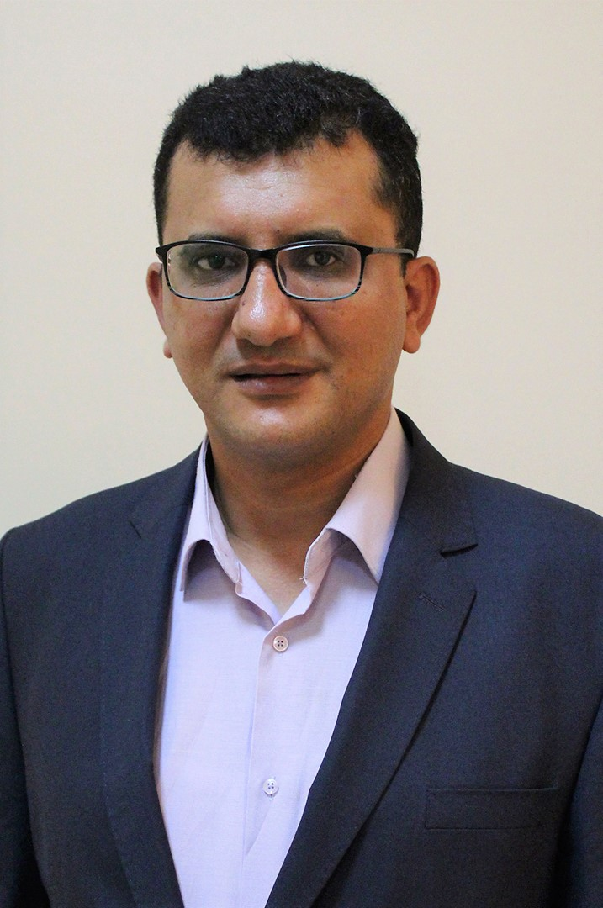

Electronic Profiles
Arab American University-Palestine [AAUP] Profile
https://www.aaup.edu/zahran.daraghma
ResearchGate Profile
https://www.researchgate.net/profile/Zahran_Daraghma
SCOPUS Profile
https://www.scopus.com/authid/detail.uri?authorId=35095003300
Google Scholar Profile
https://scholar.google.com/citations?user=E74CVAMAAAAJ&hl=en
Open Researcher and Contributor ID [ORCID] Profile
https://orcid.org/0000-0003-0403-2694

Personal Information
Place of Birth: Tubas, West bank.
Nationality: Palestinian.
Marital status: Married, four Children (Hala, Mohammad, Ibrahim and Ali).

Academic Qualifications
- Full Professor in Accounting. (2021). Arab American University.
- Associate Professor in Accounting. (2011). Arab American University.
- Ph.D. in Accounting. (2005). The Arab Academy for Management, Banking and Financial Sciences.
- MSc in Accounting. (2002). The Arab Academy for Management, Banking and Financial Sciences.
- BA in Accounting. (2000). An-Najah University.
- Certificate of General Secondary Education Examination. (1996). Scientific Stream, Tubas Secondary Boys School, Tubas- Palestine.

Leadership and Teaching Experience
- 2021 – Present: Full Professor - Accounting. Faculty of Administrative and Financial Sciences. The Arab American University –Palestine.
- 2020 - Present: Member of Students Appeals Committee. The Arab American University –Palestine.
- 2019 – 2021: Associate Professor. Faculty of Administrative and Financial Sciences. The Arab American University –Palestine.
- 2018 - 2019: Training Coordinator. Faculty of Administrative and Financial Sciences. The Arab American University –Palestine.
- 2016 - 2019: Assistant to the Dean. Faculty of Administrative and Financial Sciences. The Arab American University –Palestine.
- 2016 – 2019: Head of Accounting Department. The Arab American University – Palestine.
- 2014 – 2015: Dean's Assistant of Scientific Research. Scientific Research Deanship. The Arab American University – Palestine.
- 2014 – 2015: Member of Editorial Board. Journal of the Arab American University.
- 2011 – 2014: Head of Accounting Department. The Arab American University – Palestine.
- 2014. Member of the students' election central committee. The Arab American University – Palestine.
- 2012 – 2013. Member of exam formulation committee. Board of professional auditing – Palestine.
- 2012. Member of the students' election central committee. The Arab American University – Palestine.
- 2011 – 2012: Member of Scientific Research Committee. Research Deanship. The Arab American University – Palestine.
- 2011: Associate Professor of Financial Accounting. The Arab American University – Palestine.
- 2010-2011: Assistant Professor, Department of Accounting, Faculty of Administrative and Financial Sciences. The Arab American University – Palestine.
- 2010 – 2011: member of self-evaluation committee - accounting department -AAUJ. According to the instructions of accreditation and quality assurance commission, higher education, Palestine.
- 2008 – 2010: Auditor, Alquds establishment for financial consultants, Abu Dis, East Jerusalem. I prepared many feasibility studies, taxes services and auditing tasks.
- 2005 – 2010: Assistant Professor, Department of Accounting, Faculty of Business and Economics, Alquds University-Abu Dis.
- 2009 – 2010: Member of students’ affair council/ central system committee – Alquds University.
- 2009-2010: Representative of business and economics faculty- students’ affairs- students’ problems. Alquds University.
- 2009-2010: Head of admission committee - master of accounting. – Alquds University.
- 2007-2008: Member of academic council – Alquds University.
- 2003-2004: Instructor, Accounting Department, University of Banking and Financial Sciences, Amman-Jordan.
- 2003: Trainer, Institute of training, University of Banking and Financial Sciences, Amman-Jordan.

Publications
- Daraghma, Z., and Ghannam, A. (). The Capabilities of the Municipalities in the West Bank to Apply the Program and Performance Budget: Empirical Study. Palestine Technical University Research Journal (PTURJ). Forthcoming.
- Anabtawi. A., and Daraghma, Z. (). ERP System Success Effect on The Internal Control System in Palestine Exchange. International Journal of Accounting, Auditing and Performance Evaluation. Forthcoming.
- Daraghma, Z., Jarrar, S. and Anabtawi. A., (). The efficiency of Accounting system of Palestinian Islamic banks. International Journal of Business and Data Analytics. Forthcoming.
- Jardaneh, L. and Daraghma, Z. (2022). Bridging credit risk using comprehensive credit analysis: evidence from Palestinian banking sector. International Journal of Business Excellence. Forthcoming and Online First Articles. DOI: 10.1504/IJBEX.2021.10046677. (Accepted).
- Alawneh, R. and Daraghma, Z. (2020). Competing Indicators of Free Cash Flows and the Usefulness: Evidence from Palestine Exchange. Academy of Accounting and Financial Studies Journal. Volume 24, Issue 3. PP 1-13.
- Zahran Daraghma. (2018). Expectation Gap in Applying the IAS 2 [Inventories]: Evidence from Palestine. Academy of Accounting and Financial Studies Journal. Volume 22, Issue 2. PP 1-16.
- Zahran Daraghma. (2019). Should the Legal and Judicial System of Palestine Keep, Amend or Abolish Income Tax? International Journal of Business, Accounting and Finance (IJBAF). Volume 13, Number 1. PP 101-119.
- Zahran Daraghma. (2016). The Impact of Foreign Ownership on the Stock Returns and Accounting Performance of the Listed Corporations in the Palestine Exchange. INFORMATION-An International Interdisciplinary Journal /ISI. Volume 19, Number 1.
- Sharif M. Abu Kars and Zahran Daraghm. (2016). The Impact of Working Capital Efficiency on Stock Returns: Evidence from Palestine Exchange. INFORMATION-An International Interdisciplinary Journal/ ISI. Accepted Volume 19, issue 7.
- Zahran Daraghma and Suhiab Jarrar. (2016). Examining the Availability of the Required Controlling Procedures that Obstruct the Logical and Physical Access to AIS: The Case of the Listed Companies in the PEX. Journal of the Arab American University. Accepted Volume 3, Issue 1.
- Raed Saad and Zahran Daraghma. (2016). Using of the Balanced Scorecard for Performance Evaluation: Empirical Evidence from the Listed Corporations in the Palestine Exchange (PEX (. International Journal of Business and Management / ERA. Volume 11, No. 3.
- Zahran Daraghma and Raed Iriqat. (2015). Exploring Economy Dependence in the Middle East Using Governmental Accounting Indicators: The Case of Palestine, Jordan & Israel. International Business Research / ERA. Vol. 9, No. 1.
- Zahran Daraghma and Suhiab Jarrar. (2015). The Existence of the Constituents of Corporate Governance Related to Auditing Task and Company Management: Empirical Evidence from the Shareholding Corporations in Palestine. Jordan Journal of Business Administration, university of Jordan. Volume 11, Number 2.
- Zahran Daraghma. (2014). The Impact of Firm's Size, and Firm's Debts Level on the Debt and Profitability Relationship of the Industrial Listed Companies in the Palestine Securities Exchange. International Journal of Finance and Accounting. Volume 3, Number 2.
- Zahran Daraghma. (2013). Predicting the Future Accounting Earnings: Empirical Evidence from the Palestine Securities Exchange. Research Journal of Finance and Accounting. Vol.4, No.17.
- Raed Al-Saad and Zahran Daraghma. (2013). Cost Accounting for healthcare organizations. Alquds open university publications. Referee book.
- Zahran Daraghma and Suhiab Jarrar. 2012. Accounting Gimmicks. Palestinian Journal of Auditor. Palestinian Association of CPA. Issue 3.
- Zahran Daraghma, and Saher Aqel. (2011). The impact of unreasonable expectations of the financial statements’ users on the audit expectations gap in Palestine. The Arab Journal of Accounting, University of Bahrain. Volume 14, issue 1. PP 8 -54.
- Zahran Daraghma and Abd-Alraoof Alsinawi. (2010). Board of Directors, Management Ownership, and Capital Structure and its Effect on Performance: The Case of Palestine Security Exchange. International journal of business and management. Volumes 5, issues 11.
- Zahran Daraghma. (2010). The Relative and Incremental Information Content of Earnings and Operating Cash Flows: Empirical Evidence from Middle East, the Case of Palestine. European Journal of economics, finance & administrative sciences, issue 22. PP 123-136.
- Ibrahim Awad and Zahran Daraghma. (2009). Testing the Weak-Form Efficiency of the Palestinian Securities Market. International Research Journal of Finance and Economics, 2009, issue 32, PP 7-17.
- Zahran Daraghma. (2008). The Influence of Firm Growth, Size, and Financial Leverage on Information Content of Operating Cash Flows and Accounting Earnings: Evidence from Jordan: Industry Sector. Arab Journal of Administrative Sciences, Kuwait University, Volume 15, Issue 3, PP. 1 – 22.
- Nasser Al-Zu’bi, Ali Al-Zu’bi and Zahran Daraghma. (2006). Toward the application of environmental auditing in Jordan, Journal of Administrative Studies: Dirasat, the University of Jordan, Volume 33, Issue 1, PP. 1 – 16.
- Zahran Daraghma, (2005). Factors Affecting the Usefulness of Cash Flows and Earnings in Explaining Security Returns: Empirical Evidence from Jordanian bourse, PhD Dissertation, Department of Accounting, University of Banking and Financial Sciences, Amman –Jordan.
- Zahran Daraghma, (2004). The Influence of Debt Structure on Relative and Incremental Information Content of Earnings and Dividends: Empirical Study, Amman Bourse. Referee Conference, accounting department, Mu'tah University, AL-Qaraq–Jordan, Conference title: Accounting in Information Age.

Forthcoming Papers
- AIS Security.
- EBIT & EAIT.
- Auditing and internal control.
- Sustainability report.
- Comparing traditional and economic performance measures for creating stock value: a perspective from Palestine

Refereeing
- Evaluation of promotions for the rank of associate professor.
- Refereeing many research papers to be published in Kadoorei Journal of Scientific Research. Palestine Technical University Kadoorei.
- Refereeing research paper to be published in An-Najah National University. Journal for Research - B (Humanities).
- Refereeing research papers to be published in Arab American University. The Journal of the Arab American University.
- Refereeing research papers to be published in many international journals.
- Refereeing university degree programs (accreditation). Ministry of education and higher education. Palestine.
- Please see my account on SCOPUS.

Research Interests
- Market Based Accounting Research.
- Quantitative Research in Accounting.

Courses Taught in University of Banking and Financial Sciences

Managerial accounting. | Advanced financial accounting.

Courses Taught in Alquds Open University (in Arabic)

Accounting I | Financial statement analysis.
Company accounting 1. | Company accounting 2.
Business essentials in English. | Managerial accounting.
Accounting theory. | Auditing.
Accounting information system. | International accounting.
Advanced Accounting.

Courses Taught in Al-Quds University – Jerusalem [Abu Dis] (in English)

Managerial accounting. | Accounting principal 1.
Accounting principal 2. | Cost accounting 1.
Cost accounting 2. | Intermediate accounting 1.
Intermediate accounting 2. | Financial analysis.
Econometrics. | Governmental and not profit accounting.
Mathematics for business students. | Taxation accounting.
Research Methodology in Accounting. | Accounting information system.
Auditing. | Research Methodology (Master).
Fundamentals of accounting, faculty of science (computer science students
Quantitative analysis and proposal writing (Master).

Courses Taught in Arab American University - Palestine (in English)

Accounting principles 1 | Accounting principles 2
Intermediate accounting I. | Intermediate accounting II.
Financial statement analysis. | Accounting Seminar.
Advanced Accounting. | Auditing and assurance services
Accounting information system. | Accounting theory.
Taxation accounting. | International Accounting.
Foundation of financial accounting (MBA). | Accounting Principles 1.
Accounting Principles 2. | Accounting Seminar or Graduation Project.
Econometric by SPSS & E-VIEWS for accounting. | Financial Markets & Institution
Financial markets & institution | Cost accounting
Accounting for governmental & non-profit | Managerial Accounting.

Courses Taught for Graduate Students (Master and Ph.D.)

Course Name | Degree
Foundation of financial accounting | MBA Program (AAUP)
Thesis I & II (Master Students) | Al-Quds University Abu Dis and the AAUP
Graduation Project (Master Students) | Al-Quds University Abu Dis
Research Methodology (Master Students) | Al-Quds University Abu Dis
Financial Accounting | (Master In accounting and Auditing) [AAUP]
Managerial Accounting | (Master In accounting and Auditing) [AAUP]
Accounting Information System | (Master In accounting and Auditing) [AAUP]
Advanced Financial Accounting | (Master In accounting and Auditing) [AAUP]
Managerial Accounting | (Ph.D. in Accounting and Finance) [AAUP]

Master theses (discussion and supervision)

# | Name of Master Student | Thesis Title | Year of Granting | Place of Granting | Discussion or Supervision
1 | Mohammad Alnajar | Evaluation of internal control system in the departments of Palestine authority | 2010 | Al-Quds University Abu Dis - Jerusalem | Examiner
2 | Iyad Abu Hilweh | Evaluation the Effect of Using Budgets on the Comprehensive Performance of Companies: Palestinian companies for Food Industries | 2011 | Al-Quds University Abu Dis - Jerusalem | Supervisor
3 | Amani Awis | The Role of Rehabilitating the Released Prisoners in Vocational Rehabilitation from their Point of View in Jenin Governorate. | 2017 | Al-Quds University Abu Dis - Jerusalem | Examiner
4 | Loay Shadeed | The Role of Tourism Sector in Economic Development in Palestine | 2018 | Arab American University Palestine | Examiner
5 | Fadi Ghrouf | The Role of Strategic Planning in Improving the Efficiency of The Members of Security Services in Ramallah Police Department | 2018 | Arab American University Palestine | Examiner
6 | Mahmuod Sameeh Hassan Nearat | The Use of Balanced Scorecard for Performance Evaluation in Industrial Corporations Listed on Palestine Securities Exchange (PSE) | 2018 | Arab American University Palestine | Supervisor
7 | Yousef Atef Amarneh | The Effect of Capital Structure on the Performance of the Listed Nonfinancial Corporation that listed on the Palestine Exchange | 2018 | Arab American University Palestine | Supervisor
8 | Lina Yousef Mahmoud Jardaneh | Investigating the Effectiveness of Using Credit Analysis Techniques to Bridge Credit Risk: Evidence from the Palestinian Banks | 2018 | Arab American University Palestine | Supervisor
9 | Yasmin Omar Tawfiq Malalha | The Role of Economic Empowerment Projects - Improving the Quality of the Situation of the Poor Families Benefiting from the Economic Empowerment Program -the Ministry of Social Development in Jenin Governorate | 2019 | Al-Quds University Abu Dis - Jerusalem | Supervisor
10 | Abedalfatah Saleem Hajji | “The Role of Programs and Performance Budget in Implementing Palestinian Strategic Plans” | 2020 | Arab American University Palestine | Examiner
11 | Adnan Ahmad Abed | The extent of progress made by the State of Palestine in the process of transition from item budget to programs budget: analytical study | 2021 | Arab American University Palestine | Examiner
12 | Jumana Abd Alrahman Rasras | The Effect of Foreign Exchange Rate fluctuations on The Financial Performance" An Applied Study On Industrial and Service Companies listed in Palestine Exchange During 2014-2019" | 2021 | Al-Quds University Abu Dis - Jerusalem | Examiner
13 | Mustafa Sharif Mustafa Younis | The Role of Program and Performance Budget in implementing the Strategic Plan: Security Sector - Palestine | 2021 | Arab American University Palestine | Examiner
14 | Amen Ahmad Mustafa Awwad | The Implications of Corona Pandemic and its Impact on Small and Medium Enterprises in the Bethlehem Governorate | 2021 | Al-Quds University Abu Dis - Jerusalem | Examiner
15 | Alaa Omer Ibdair | "Towards an Entrepreneurial University Model and Possibilities of Implementation in Palestine: Evidence from Al-Quds University" | 2022 | Al-Quds University Abu Dis - Jerusalem | Examiner
16 | Ashraf Mohammad Abdel-Rahman Ghannam | The Capabilities of the Municipalities in the West Bank to Apply the Program and Performance Budget | 2022 | Al-Quds University Abu Dis - Jerusalem | Supervisor

Computer Skills
- Microsoft Windows, and Office (Word, Excel, Access, and PowerPoint) - High Skills.
- Statistical Packages including E-Views, Limdep -Nlogit (Econometrics), and SPSS.

